9).Create a simple cloud software application for Hospital information system for SIMATS Hospital using any Cloud Service Provider to demonstrate SaaS with fields of patient name, age, address, phone, email, Attender name, attender phone, doctor name, diseases, etc

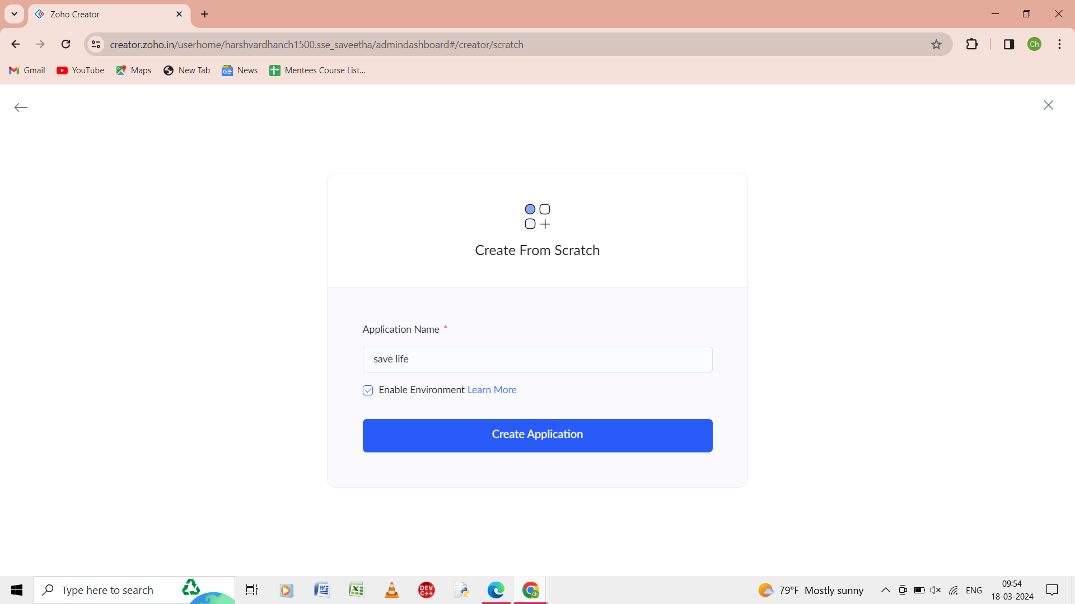

Step 1: from the scratch give the name of the application as save life.

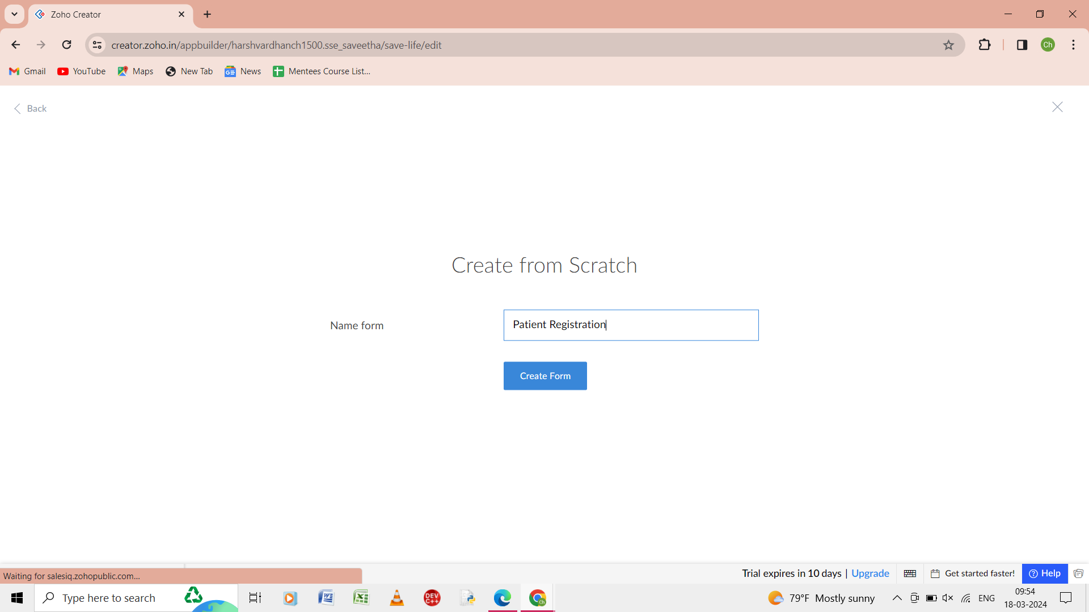

Step 2: from the scratch give name of the form as patient registration.

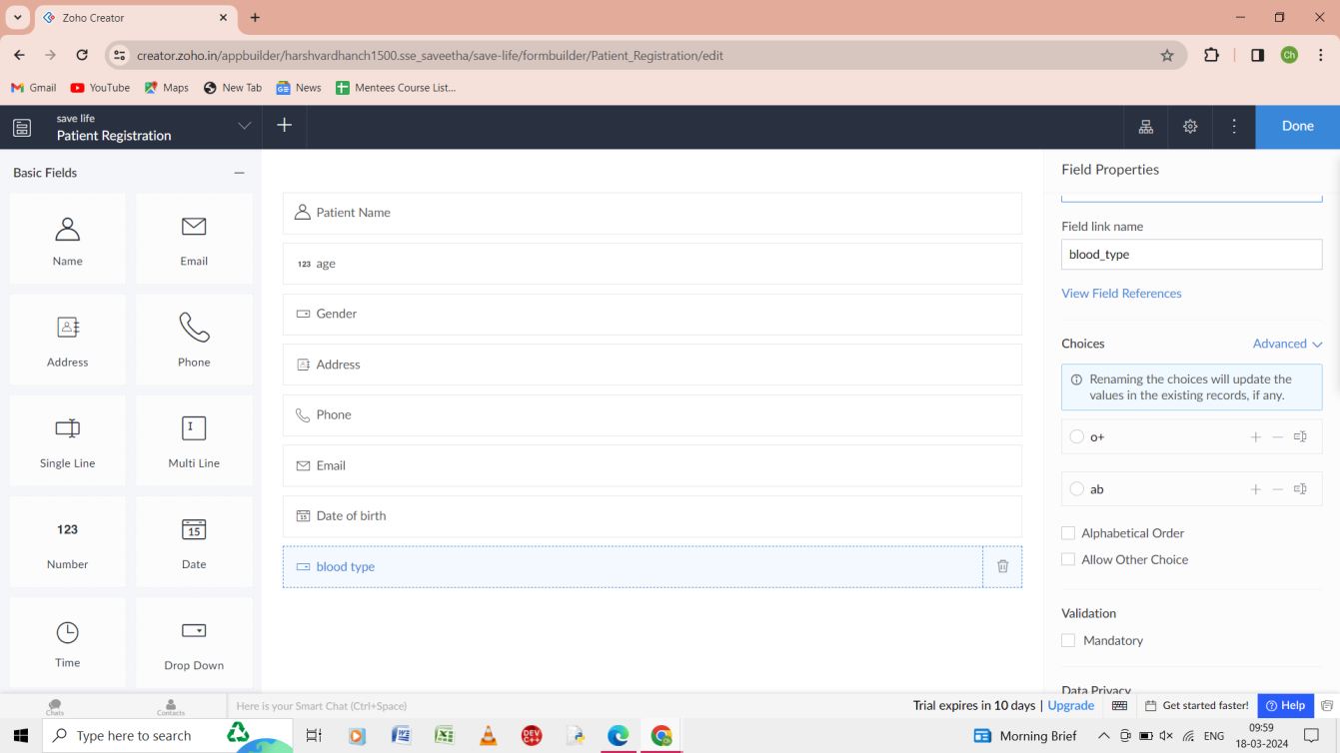

Step 3: in the patient registration form give the details as patient name, age, gender, address, phone, date of birth, blood group.

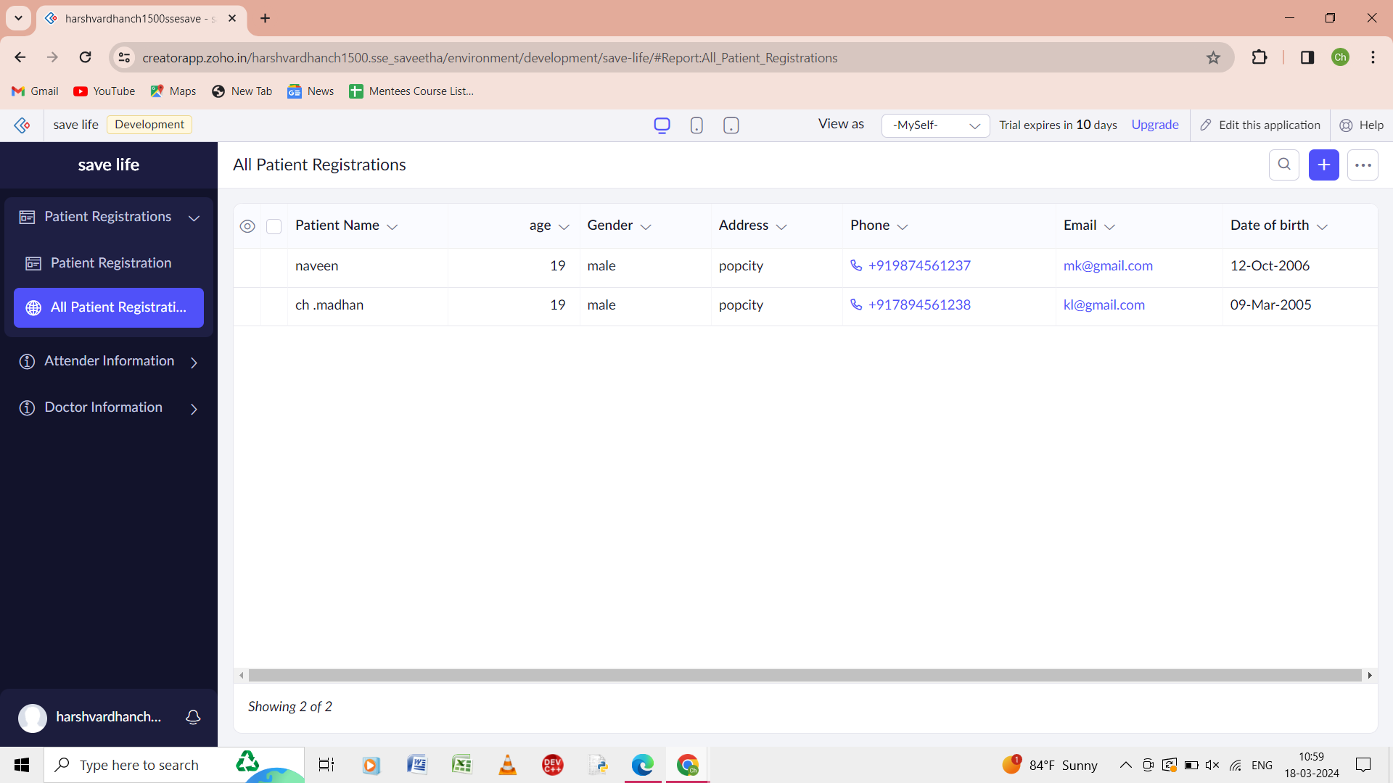

Step 4: the report of the all the patient registration is shown.

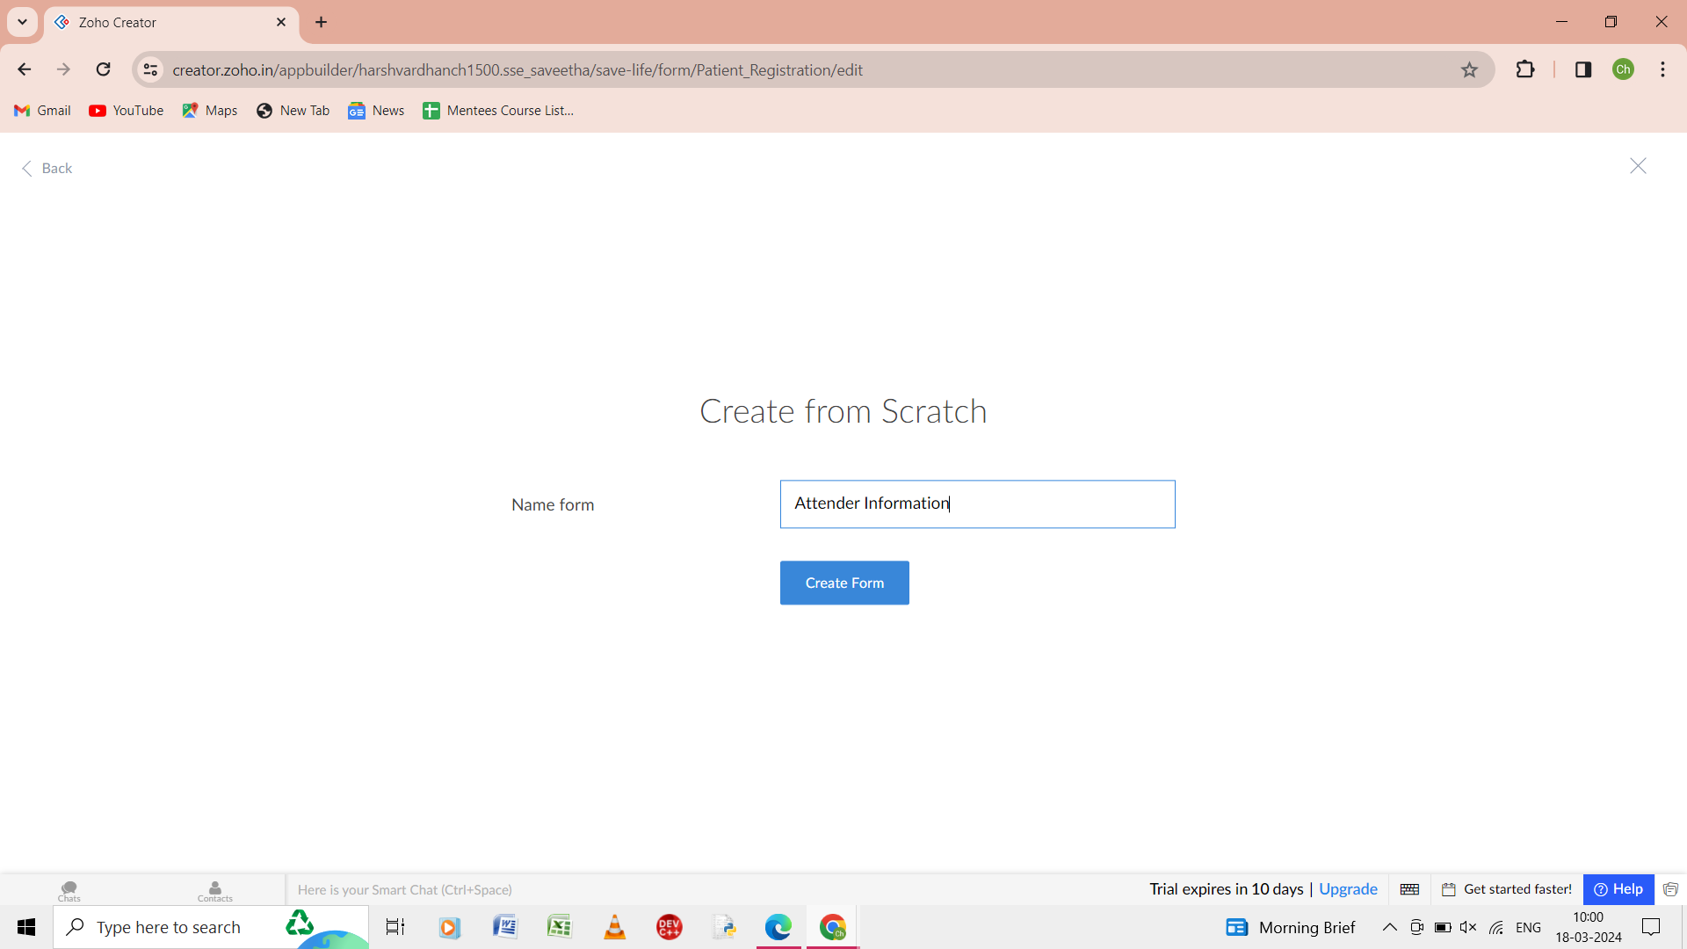

Step 5: from the scratch give the form of the name as attender information.

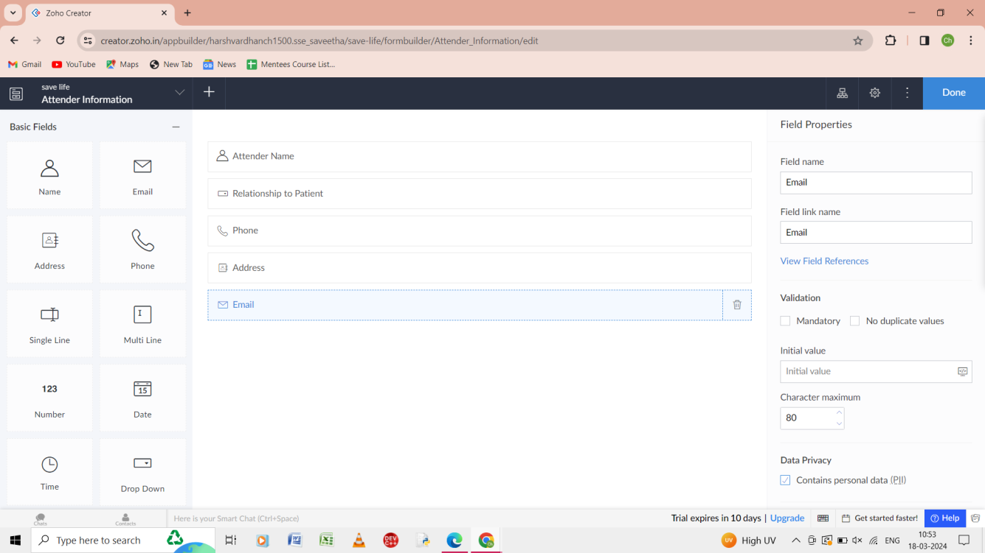

Step 6: in the form of attender information give the details attender name, relationship to patient, phone, address, email.

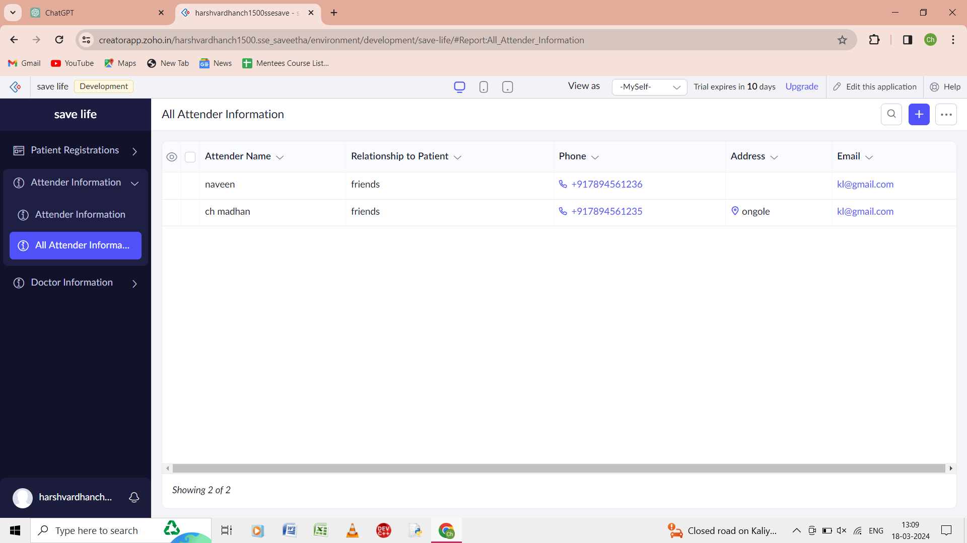

Step 7:the report of all the attender information is shown.

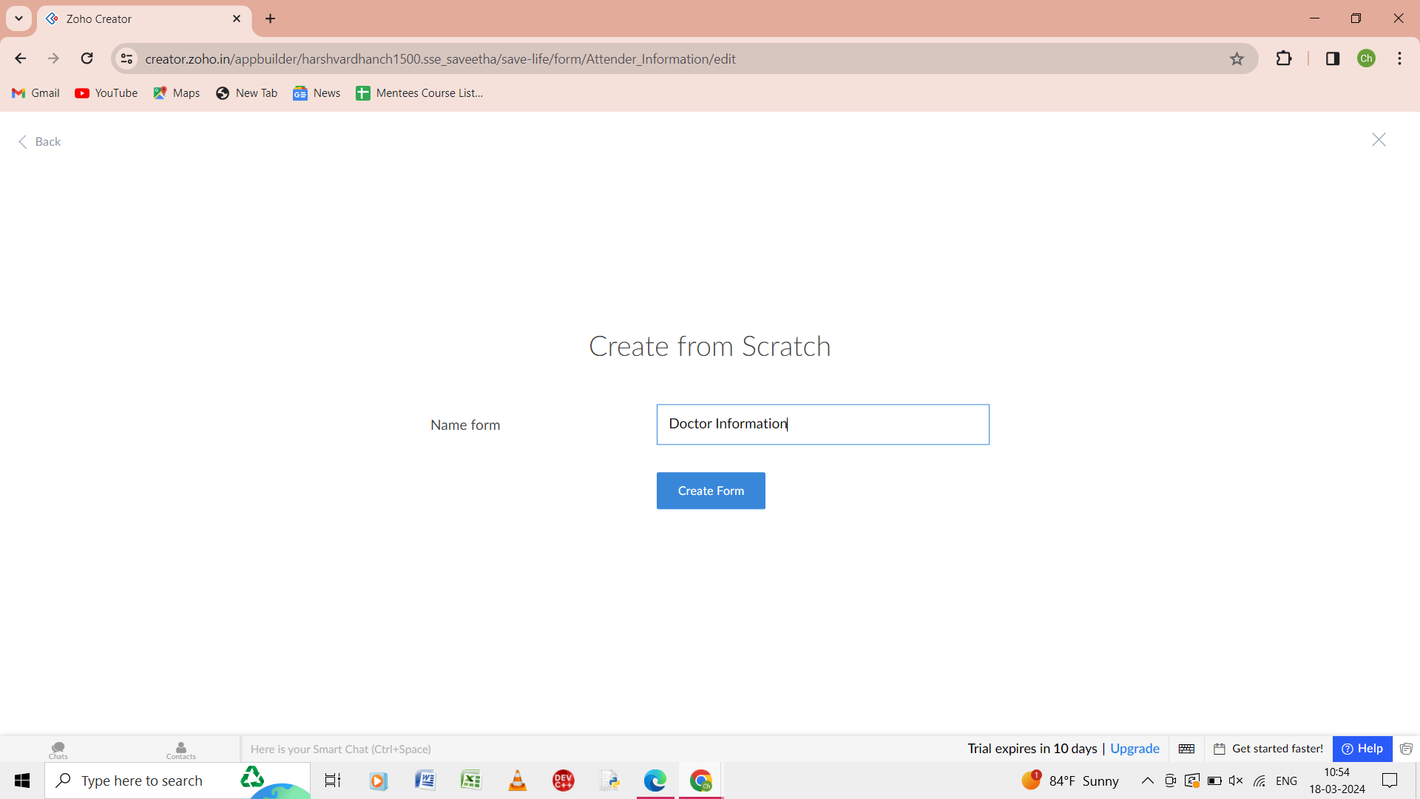

Step 8: from the scratch give name of the form as doctor information.

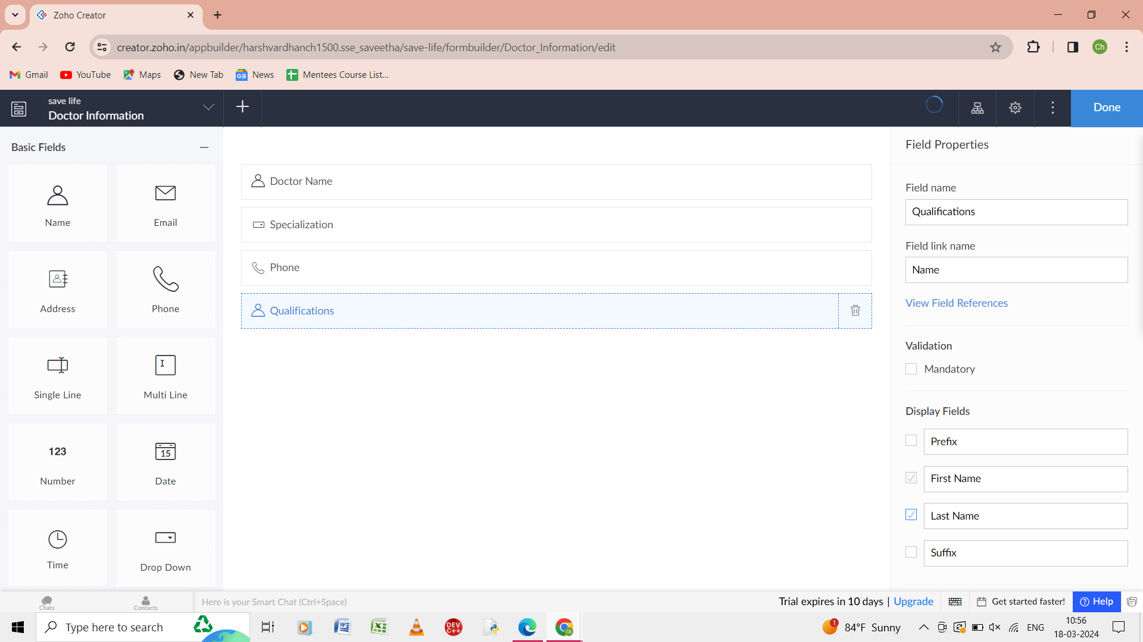

Step 9: in the doctor information form give the details as doctor name, specialization, phone, qualification.

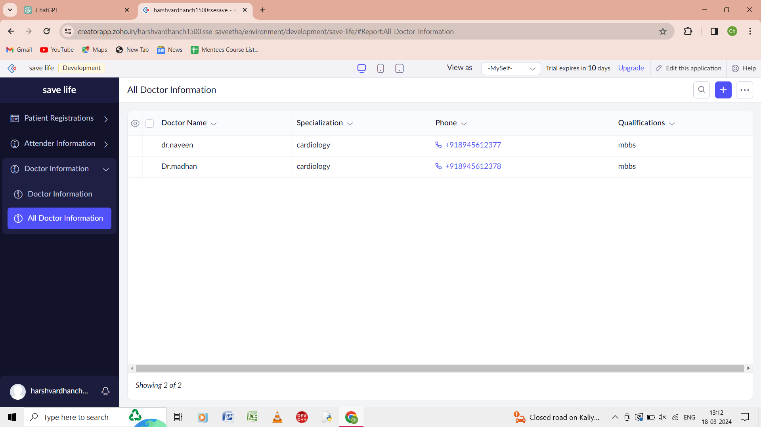

Step 10: the report of all the doctor information is shown.